Architect

A Grand Design

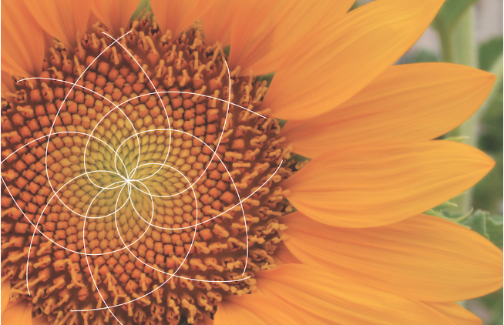

M Croteau

www.vocebonita.xyz

**Is evolution real?** The answer is no, evolution is not real, it does not exist. We were all created, **all created independently**, each race independently in order to create a unique and different World, a World that could not be created with one race of people, each one of us Original in Design.

**Are we really Original Designs?**There are distinct differences between all races here on Earth. All is needed is about 10 minutes of time, mixed with critical thinking while observing imagery. Observe a few cultures some of which are neighboring and ask how did they come to be. Were they created independently or originate from one group? Observe the following pages. Was each race created independently, or one created with adaption and evolution?

The answer independently.

Lets take a look...

Africa

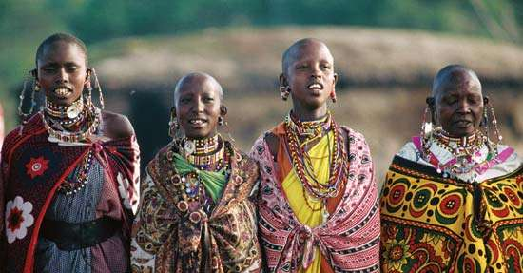

India

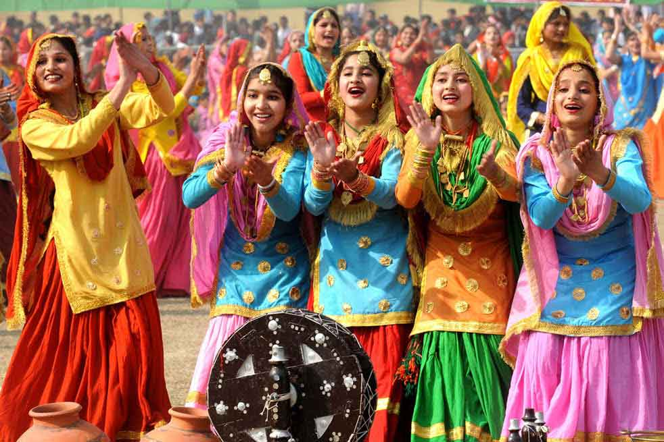

Germany



Saudi Arabia

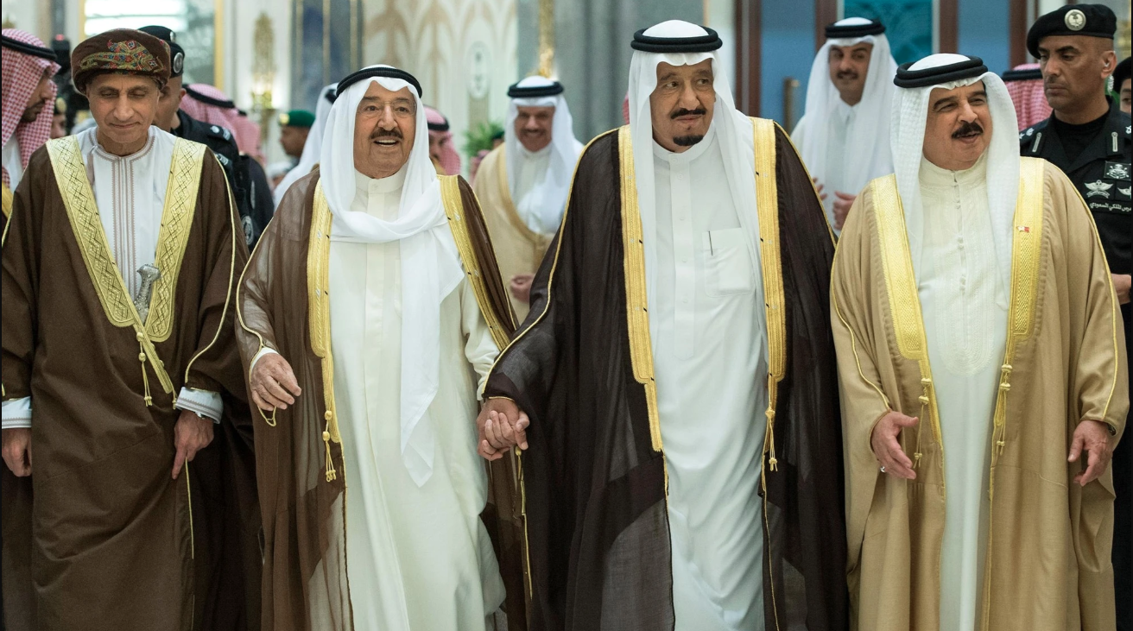

Russia

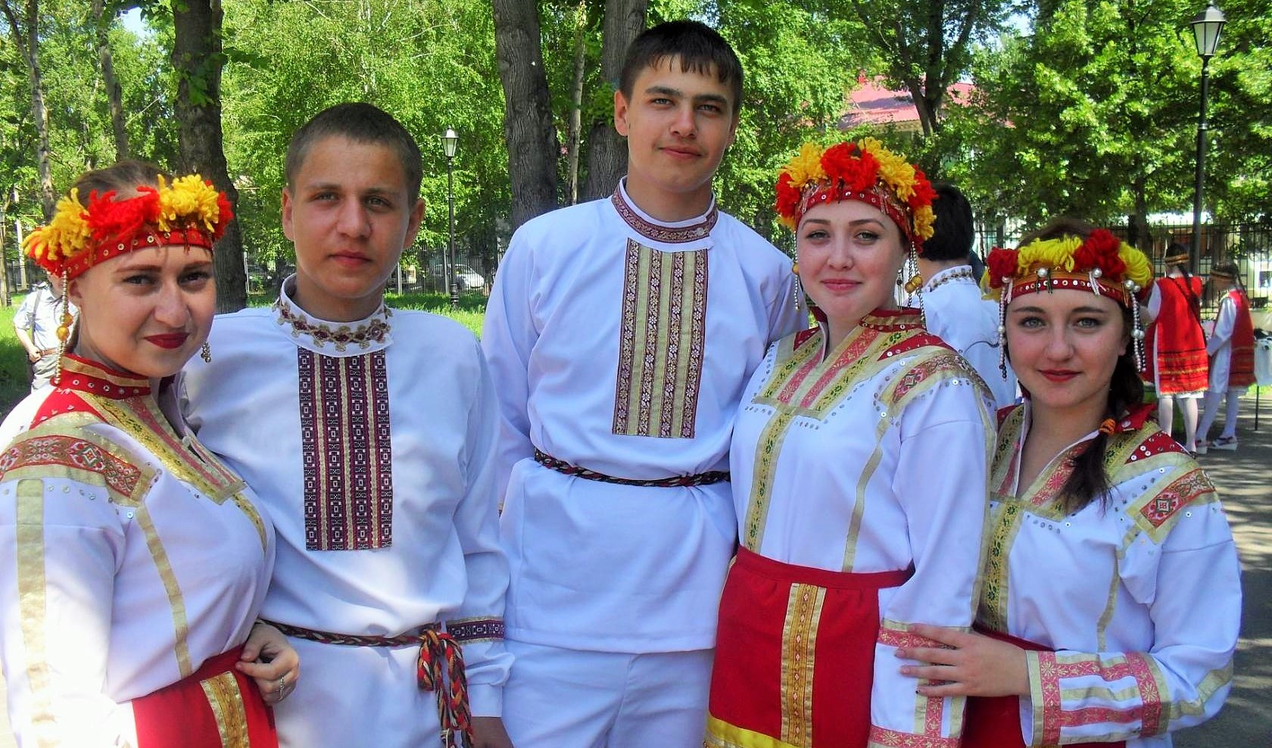

China



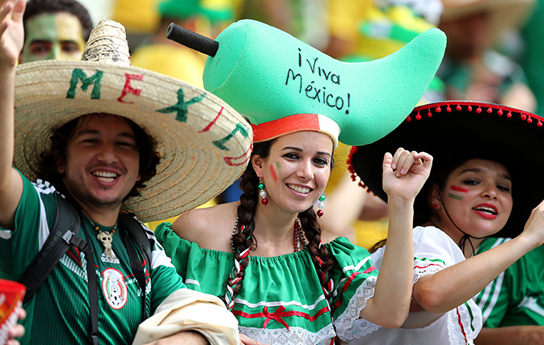Mexico

Brazil



We are all different. It is plain as day.

There is no environmental component, weather pattern or diet that shaped us over time.

Looking at the images above, you can start to think about the cultures, architecture, food and lives of the people. Each are different in their own way. Start to combine the cultures and people and you have something unique, something different, something new that the our Grand Architect or God could not create with one race. Do you understand? Let me explain:

There is only so much preference data that can be stored within a human being. If one race or culture occupied the entire planet, all pockets of civilization would look the same, however, mix in some variety, (more than one race) and you have the possibility of cultures working together to create a unique civilization, something that one race could not create alone. Like ingredients to an ultimate recipe, we each group or race of people are designed to part of a master design… a design so Grand so different no one person can grasp.

… This includes architecture, music, culinary arts, spirits, dance and movement how we interact, anything and everything, we have the possibility of creating a unique and different World, it can happen so long as every human being is allowed to live freely. Change could happen, and it could happen organically.

So you want to challenge the existence of God and the idea of creationism...

**The Existence of God...** It can be proven within the definitive design in nature, and mathematics within the design. Take a look at the image on the next page.

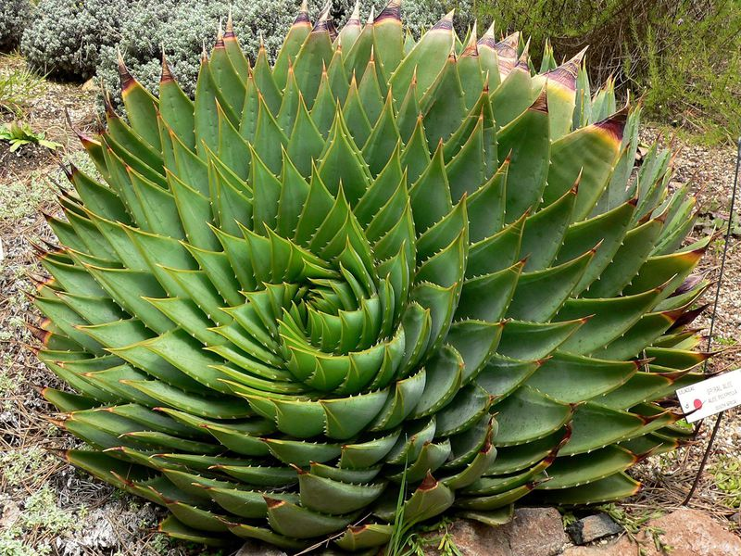

Quick example, Let’s look at the aloe plant above. Do you see uniformity and the math within the design? The point of this, it was created, we were created, all plant and animal life created. No evolution.

**Proof that we were created. Lets do an exercise…**

I want you to take a look at your hand. Look at your hand from the side, start to wiggle your fingers and move your hand back and forth. Do this in front of a plant.





It’s important that you perform this exercise next to or in front of a plant. Spend at least 15 seconds performing this exercise and ask the question while performing this, “Does the hand belong? Is the human hand foreign?”

The hand is foreign, the human existence is foreign, we all together everything human is foreign.

We did not grow or originate from Earth. We were created by God, a Grand Architect.

Let’s consider the single celled organism theory, that we all originated including animal life from a single celled organism. The amount of data that would need to reside within the starting single celled organism would be very large. In addition, it cannot be stressed enough that life on Earth would be very very strange if evolution were true. Evolution does not exist, we did not originate from a single celled organism, we were all created… created by God.

There is only so much preference data that can be stored within DNA…

**The**

**Solar System...**

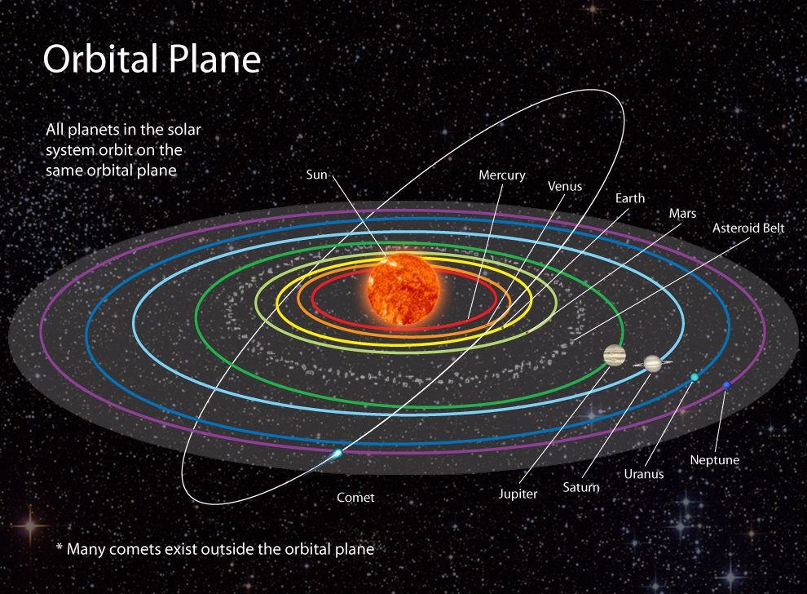

The solar system consists of 8 planets that orbit the Sun. These planets orbit in a horizontal fashion. While orbiting these planets tilt and rotate… its systematic, uniform in design. An Architect is at play...

**Again, why different cultures? One last time…**

... There are differences in preferences between different races or organizations of people. If two different races were to bare a child, the preferences for that child would be unique… a blend. He or she would have preferences from both cultures and may in turn prefer something new… again a blend. You don’t even have to believe in intercultural relationships in order to believe in the Grand design, again blends can be something as simple as food or drink, something like Cherry Sprite, Ginger Ale with Lemonade or Chicken and Waffles all can be seen as simple blends.

It has an opportunity of happening…

**!ඔබට ස්තුතියි**

This is “Thank you!” in Sinhala, language of Sri Lanka. It is probably the most interesting language of all.

Blacks before women → buy plants

Whites before women → buy plants

°Δ Ξ

Thou shall promote and foster ones culture

Thou shall encourage disaggregated love

Sweden

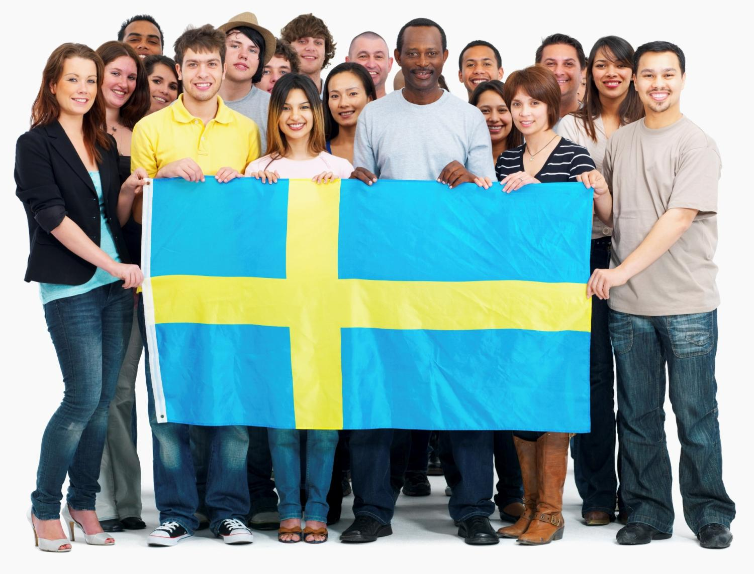France



Japan

South Korea



[www.vocebonita.xyz](http://www.vocebonita.xyz/)

Mike Croteau